How the Optimizer Transforms SQL Statements
SQL is a very flexible query language; there are often many statements you could use to achieve the same goal. Sometimes, the optimizer (Query Transformer) transforms one such statement into another that achieves the same goal if the second statement can be executed more efficiently.
This section discusses the following topics:
- How the CBO Transforms ORs into Compound Queries
- How the CBO Unnests Subqueries
- How the CBO Merges Views
- How the CBO Pushes Predicates
- How the CBO Executes Compound Queries
See Also:
"Understanding Joins" for additional information about optimizing statements that contain joins, semi-joins, or anti-joins

How the CBO Transforms ORs into Compound Queries
If a query contains a WHERE clause with multiple conditions combined with OR operators, then the optimizer transforms it into an equivalent compound query that uses the UNION ALL set operator, if this makes the query execute more efficiently:
- If each condition individually makes an index access path available, then the optimizer can make the transformation. The optimizer chooses an execution plan for the resulting statement that accesses the table multiple times using the different indexes and then puts the results together.
- If any condition requires a full table scan because it does not make an index available, then the optimizer does not transform the statement. The optimizer chooses a full table scan to execute the statement, and Oracle tests each row in the table to determine whether it satisfies any of the conditions.
- For statements that use the CBO, the optimizer might use statistics to determine whether to make the transformation, by estimating and then comparing execution costs of the original statement and the resulting statement.
- The CBO does not use the OR transformation for IN-lists or ORs on the same column; instead, it uses the INLIST iterator operator.
Example 2-37 shows how an OR query is transformed into a compound query. In this example, the WHERE clause contains two conditions combined with an OR operator.

Example 2-37 Transforming an OR Query into a Compound Query
Initial Query
SELECT *
FROM employees
WHERE job_id = 'ST_CLERK'
OR department_id = 50;

If there are indexes on both the job_id and department_id columns, then the optimizer might transform this query into the following equivalent query:
Optimized Query
SELECT *
FROM employees
WHERE job_id = 'ST_CLERK'
UNION ALL
SELECT *
FROM employees
WHERE department_id = 50
AND job_id <> 'ST_CLERK';

When the CBO is deciding whether to make a transformation, the optimizer compares the cost of executing the original query using a full table scan with that of executing the resulting query.
The execution plan for the transformed statement might look like the illustration in Figure 2-1. The shaded boxes indicate steps that physically retrieve data and the clear boxes indicate steps that operate on data returned from the previous step.

Figure 2-1 Execution Plan for a Transformed Query Containing OR
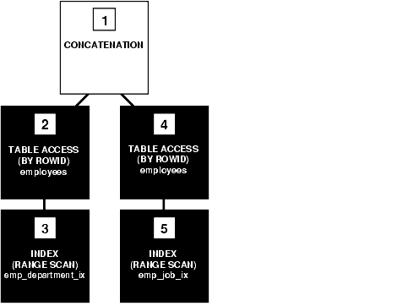
Text description of the illustration pfgrf199.gif
To execute the transformed query, Oracle performs the steps in Figure 2-1 in the following order:
- Steps 3 and 5 scan the indexes on the job_id and department_id columns using the conditions of the component queries. These steps obtain rowids of the rows that satisfy the component queries.
- Steps 2 and 4 use the rowids from steps 3 and 5 to locate the rows that satisfy each component query.
- Step 1 puts together the row sources returned by steps 2 and 4.
If either the job_id column or the department_id column is not indexed, then the optimizer does not even consider the transformation, because the resulting compound query would require a full table scan to execute one of its component queries. Executing the compound query with a full table scan in addition to an index scan could not possibly be faster than executing the original query with a full table scan.
Example 2-38 shows the kind of query that is not transformed. The query in this example assumes that there is an index on the last_name column only:

Example 2-38 Query Containing OR That Is Not Transformed
SELECT *
FROM employees
WHERE last_name = 'Smith'
OR salary > commission_pct*100000;

Transforming this query would result in the compound query in Example 2-39.

Example 2-39 Compound Query Containing OR That Is Transformed
SELECT *
FROM employees
WHERE last_name = 'Smith'
UNION ALL
SELECT *
FROM employees
WHERE salary > commission_pct*100000;

Because the condition in the WHERE clause of the second component query (salary > commission_pct) does not make an index available, the compound query requires a full table scan. For this reason, the optimizer does not make the transformation, but chooses a full table scan to execute the original statement.

How the CBO Unnests Subqueries
To optimize a complex statement, the optimizer chooses to do one of the following:
- Transform the complex statement into an equivalent join statement, and then optimize the join statement
- Optimize the complex statement as it is
The optimizer transforms a complex statement into a join statement whenever the resulting join statement is guaranteed to return exactly the same rows as the complex statement. This transformation allows Oracle to execute the statement by taking advantage of join optimizer techniques.
Example 2-40 shows how the optimizer uses a join to unnest a subquery. The complex statement in this example selects all rows from the orders table for which owners appear in the customers table.

Example 2-40 How the CBO Unnests Subqueries
Initial Query
SELECT *
FROM orders
WHERE customer_id IN
(SELECT customer_id FROM customers);

If the customer_id of the customers table is a primary key or has a UNIQUE constraint, then the optimizer can transform the complex query into the following join statement that is guaranteed to return the same data:
Optimized Query
SELECT orders.*
FROM orders, customers
WHERE orders.customer_id = customers.customer_id;

To execute this statement, Oracle performs a nested-loops join operation. The execution plan for this statement might look like Figure 2-2.

Figure 2-2 Execution Plan for a Nested Loops Join
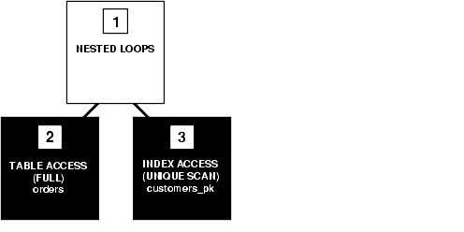
Text description of the illustration pfgrf200.gif
If the optimizer cannot transform a complex statement into a join statement, then it chooses execution plans for the parent statement and the subquery as though they were separate statements. Oracle then executes the subquery and uses the rows returned to execute the parent query.
Example 2-41 shows the kind of statement is not transformed. The complex statement in this example returns all rows from the customers table that have credit limits greater than the average credit limit.

Example 2-41 Complex Statement That Is Not Transformed
SELECT *
FROM customers
WHERE credit_limit >
(SELECT AVG(credit_limit) FROM customers);

No join statement can perform the function of this statement, so the optimizer does not transform the statement.
Note:
Complex queries whose subqueries contain aggregate functions such as AVG cannot be transformed into join statements.

How the CBO Merges Views
To merge the view's query into a referencing query block in the accessing statement, the optimizer replaces the name of the view with the names of its base tables in the query block and adds the condition of the view's query's WHERE clause to the accessing query block's WHERE clause.
This optimization applies to select-project-join views, which are views that contain only selections, projections, and joins. This means that these views do not contain items such as set operators, aggregate functions, DISTINCT, GROUP BY, and CONNECT BY. See "Mergeable and Nonmergeable Views".
Example 2-42 shows how the CBO merges views. The view in this example is of all employees who work in department 10:

Example 2-42 How the CBO Merges Views
CREATE VIEW emp_10
AS SELECT employee_id, last_name, job_id, manager_id, hire_date, salary,
commission_pct, department_id
FROM employees
WHERE department_id = 10;

The following query accesses the view. The query selects the Ids greater than 170 of employees who work in department 10:
SELECT employee_id
FROM emp_10
WHERE employee_id > 170;

The optimizer transforms the query into the following query that accesses the view's base table:
SELECT employee_id
FROM employees
WHERE department_id = 10
AND employee_id > 170;

If there are indexes on the department_id or employee_id columns, then the resulting WHERE clause makes them available.

Mergeable and Nonmergeable Views
The optimizer can merge a view into a referencing query block when the view has one or more base tables, provided the view does not contain any of the following:
- Set operators (UNION, UNION ALL, INTERSECT, MINUS)
- A CONNECT BY clause
- A ROWNUM pseudocolumn
- Aggregate functions (AVG, COUNT, MAX, MIN, SUM) in the select list
When a view contains one of the following structures, it can be merged into a referencing query block only if Complex View Merging is enabled:
- A GROUP BY clause
- A DISTINCT operator in the select list
View merging is not possible for a view that has multiple base tables, if it is on the right side of an outer join. However, if a view on the right side of an outer join has only one base table, then the optimizer can use complex view merging, even if an expression in the view can return a nonnull value for a NULL.
If a query has a CURSOR expression, then no view merging will take place, even for views which would normally be mergeable. An example is the following:
CREATE VIEW emp_v AS
SELECT last_name,employee_id FROM employees;
SELECT CURSOR(select * from sys.dual), last_name, employee_id from emp_v;

This query will not merge the emp_v view.

Complex View Merging
If a view's query contains a GROUP BY clause or DISTINCT operator in the select list, then the optimizer can merge the view's query into the accessing statement only if complex view merging is enabled. Complex merging of a view with a GROUP BY clause is illustrated in Example 2-43.
Complex merging can also be used to merge an IN subquery into the accessing statement if the subquery is uncorrelated, as shown in Example 2-44. Complex merging is not cost-based; it must be enabled with the initialization parameter OPTIMIZER_FEATURES_ENABLE or the MERGE hint. Without this hint or parameter setting, the optimizer uses another approach, pushing predicates.

Example 2-43 How the CBO Merges a View with a GROUP BY Clause
The view avg_salary_view contains the average salaries for each department:
CREATE VIEW avg_salary_view AS
SELECT department_id, AVG(salary) AS avg_sal_dept,
FROM employees
GROUP BY department_id;

If complex view merging is enabled, then the optimizer can transform the following query, which finds the average salaries of departments in London:
SELECT departments.location_id, avg_sal_dept
FROM departments, avg_salary_view
WHERE departments.department_id = avg_salary_view.department_id
AND departments.location_id = 2400;

into the following query:
SELECT departments.loc, AVG(salary)
FROM departments, employees
WHERE departments.department_id = employees.department_id
AND departments.location_id = 2400
GROUP BY departments.rowid, departments.location_id;

The transformed query accesses the view's base table, selecting only the rows of employees who work in London and grouping them by department.

Example 2-44 How the CBO Merges an IN Subquery
Complex merging can be used for an IN clause with a noncorrelated subquery, as well as for views. The view min_salary_view contains the minimum salaries for each department:
CREATE VIEW min_salary_view AS
SELECT department_id, MIN(salary) min_sal
FROM employees
GROUP BY department_id;

If complex merging is enabled, then the optimizer can transform the following query, which finds all employees who earn the minimum salary for their department in London:
SELECT employees.last_name, employees.salary
FROM employees, departments
WHERE (employees.department_id, employees.salary) IN
(select department_id, min_sal from min_salary_view)
AND employees.department_id = departments.department_id
AND departments.location_id = 2400;

into the following query (where e1 and e2 represent the employees table as it is referenced in the accessing query block and the view's query block, respectively):
SELECT e1.last_name, e1.salary
FROM employees e1, departments, employees e2
WHERE e1.department_id = departments.department_id
AND departments.location_id = 2400
AND e1.department_id = e2.department_id
GROUP BY e1.rowid, departments.rowid, e1.last_name, e1.salary
HAVING e1.salary = MIN(e2.salary);

How the CBO Pushes Predicates
The optimizer can transform a query block that accesses a nonmergeable view by pushing the query block's predicates inside the view's query. Examples 2-45 and 2-46 illustrate this process.
In Example 2-45, the two_emp_tables view is the union of two employee tables. The view is defined with a compound query that uses the UNION set operator.

Example 2-45 How the CBO Pushes Predicates - the UNION Set Operator
CREATE VIEW two_emp_tables
(employee_id, last_name, job_id, manager_id, hire_date, salary,
commission_pct, department_id) AS
SELECT employee_id, last_name, job_id, manager_id, hire_date, salary,
commission_pct, department_id
FROM emp1
UNION
SELECT employee_id, last_name, job_id, manager_id, hire_date,
salary, commission_pct, department_id
FROM emp2;

The following query accesses the view. The query selects the IDs and names of all employees in either table who work in department 50:
SELECT employee_id, last_name
FROM two_emp_tables
WHERE department_id = 50;

Because the view is defined as a compound query, the optimizer cannot merge the view's query into the accessing query block. Instead, the optimizer can transform the accessing statement by pushing its predicate, the WHERE clause condition (department_id = 50), into the view's compound query.
The resulting statement looks like the following:
SELECT employee_id, last_name
FROM ( SELECT employee_id, last_name, job_id, manager_id, hire_date,
salary, commission_pct, department_id
FROM emp1
WHERE department_id = 50
UNION
SELECT employee_id, last_name, job_id, manager_id, hire_date,
salary, commission_pct, department_id
FROM emp2
WHERE department_id = 50 );

If there is an index on the department_id column, then the resulting WHERE clauses make it available.
Figure 2-3 shows the execution plan of the resulting statement.

Figure 2-3 Accessing a View Defined with the UNION Set Operator
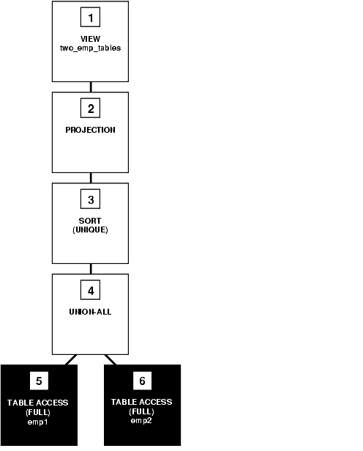
Text description of the illustration pfgrf201.gif
To execute this statement, Oracle performs the steps in Figure 2-3 in the following order:
- Steps 5 and 6 perform full scans of the emp1 and emp2 tables.
- Step 4 performs a UNION-ALL operation returning all rows returned by either step 5 or step 6, including all copies of duplicates.
- Step 3 sorts the result of step 4, eliminating duplicate rows.
- Step 2 extracts the desired columns from the result of step 3.
- Step 1 indicates that the view's query was not merged into the accessing query.
In Example 2-46, the view emp_group_by_deptno contains the department number, average salary, minimum salary, and maximum salary of all departments that have employees.

Example 2-46 How the CBO Pushes Predicates - the GROUP BY Clause
CREATE VIEW emp_group_by_deptno
AS SELECT department_id,
AVG(salary) avg_sal,
MIN(salary) min_sal,
MAX(salary) max_sal
FROM employees
GROUP BY department_id;

The following query selects the average, minimum, and maximum salaries of department 50 from the emp_group_by_deptno view:
SELECT *
FROM emp_group_by_deptno
WHERE department_id = 50;

The optimizer transforms the statement by pushing its predicate (the WHERE clause condition) into the view's query. The resulting statement looks like the following:
SELECT department_id,
AVG(salary) avg_sal,
MIN(salary) min_sal,
MAX(salary) max_sal,
FROM employees
WHERE department_id = 50
GROUP BY department_id;

If there is an index on the department_id column, then the resulting WHERE clause makes it available. Figure 2-4 shows the execution plan for the resulting statement. The execution plan uses an index on the department_id column.

Figure 2-4 Accessing a View Defined with a GROUP BY Clause
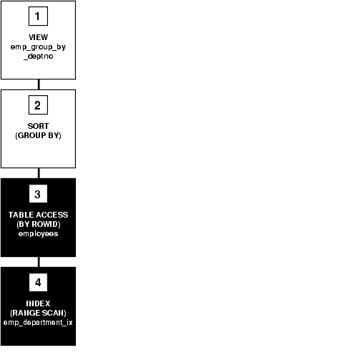
Text description of the illustration pfgrf202.gif
To execute this statement, Oracle performs the steps in Figure 2-4 in the following order:
- Step 4 performs a range scan on the index emp_department_ix (an index on the department_id column of the employees table) to retrieve the rowids of all rows in the employees table with a department_id value of 50.
- Step 3 accesses the employees table using the rowids retrieved by step 4.
- Step 2 sorts the rows returned by step 3 to calculate the average, minimum, and maximum salary values.
- Step 1 indicates that the view's query was not merged into the accessing query.

How the CBO Applies an Aggregate Function to the View
The optimizer can transform a query that contains an aggregate function (AVG, COUNT, MAX, MIN, SUM) by applying the function to the view's query.
The query in Figure 2-47 accesses the emp_group_by_deptno view defined in Figure 2-46. The query derives the averages for the average department salary, the minimum department salary, and the maximum department salary from the employee table.

Example 2-47 How the CBO Applies an Aggregate Function to a View
SELECT AVG(avg_sal), AVG(min_sal), AVG(max_sal)
FROM emp_group_by_deptno;

The optimizer transforms this statement by applying the AVG aggregate function to the select list of the view's query:
SELECT AVG(AVG(salary)), AVG(MIN(salary)), AVG(MAX(salary))
FROM employees
GROUP BY department_id;

Figure 2-5 shows the execution plan of the resulting statement.

Figure 2-5 Applying Aggregate Functions to a View Defined with GROUP BY Clause
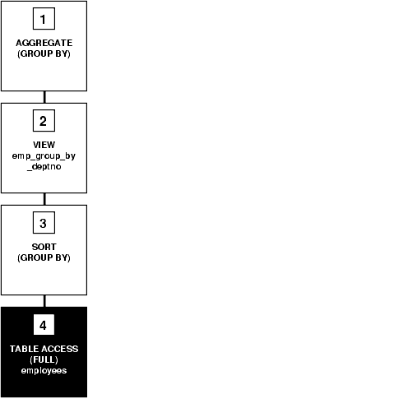
Text description of the illustration pfgrf203.gif
To execute this statement, Oracle performs the steps in Figure 2-5 in the following order:
- Step 4 performs a full scan of the employees table.
- Step 3 sorts the rows returned by step 4 into groups based on their department_id values and calculates the average, minimum, and maximum salary value of each group.
- Step 2 indicates that the view's query was not merged into the accessing query.
- Step 1 calculates the averages of the values returned by step 2.

How the CBO Executes Views in Outer Joins
For a view that is on the right side of an outer join, the optimizer can use one of two methods, depending on how many base tables the view accesses:
- If the view has only one base table, then the optimizer can use view merging.
- If the view has multiple base tables, then the optimizer can push the join predicate into the view.

How the CBO Accesses the View's Rows with the Original Statement
The optimizer cannot transform all statements that access views into equivalent statements that access base table(s). For example, if a query accesses a ROWNUM pseudocolumn in a view, then the view cannot be merged into the query, and the query's predicate cannot be pushed into the view.
To execute a statement that cannot be transformed into one that accesses base tables, Oracle issues the view's query, collects the resulting set of rows, and then accesses this set of rows with the original statement as though it were a table. Example 2-48 illustrates this process.

Example 2-48 How the CBO Accesses the View's Rows
Consider the emp_group_by_deptno view defined in Figure 2-46:
CREATE VIEW emp_group_by_deptno
AS SELECT department_id,
AVG(salary) avg_sal,
MIN(salary) min_sal,
MAX(salary) max_sal
FROM employees
GROUP BY department_id;

The following query accesses this view. The query joins the average, minimum, and maximum salaries from each department represented in the view to the name and location of the department in the departments table.
SELECT emp_group_by_deptno.department_id, avg_sal, min_sal,
max_sal, department_name, location_id
FROM emp_group_by_deptno, departments
WHERE emp_group_by_deptno.department_id = departments.department_id;

Because there is no equivalent statement that accesses only base tables, the optimizer cannot transform this statement. Instead, the optimizer chooses an execution plan that issues the view's query and then uses the resulting set of rows as it would the rows resulting from a table access.
Figure 2-6 shows the execution plan for this statement.

Figure 2-6 Joining a View Defined with a GROUP BY Clause to a Table
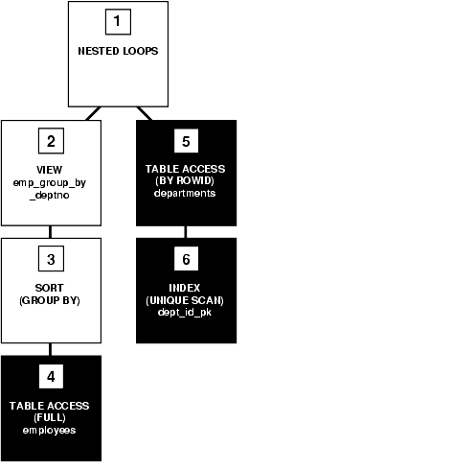
Text description of the illustration pfgrf204.gif
To execute this statement, Oracle performs the steps in Figure 2-6 in the following order:
- Step 4 performs a full scan of the employees table.
- Step 3 sorts the results of step 4 and calculates the average, minimum, and maximum salary values selected by the query for the emp_group_by_deptno view.
- Step 2 used the data from the previous two steps for a view.
- For each row returned by step 2, step 6 uses the department_id value to perform a unique scan of the dept_id_pk index.
- Step 5 uses each rowid returned by step 6 to locate the row in the departments table with the matching department_id value.
- Oracle combines each row returned by step 2 with the matching row returned by step 5 and returns the result.

How the CBO Executes Compound Queries
To choose the execution plan for a compound query, the optimizer chooses an execution plan for each of its component queries, and then combines the resulting row sources with the union, intersection, or minus operation, depending on the set operator used in the compound query. Examples 2-49, 2-50 and 2-51 illustrate the process.
The query in Example 2-49 uses the UNION ALL operator to select all occurrences of all parts in either the orders1 table or the orders2 table.

Example 2-49 How the CBO Executes Compound Queries with UNION ALL
SELECT part FROM orders1
UNION ALL
SELECT part FROM orders2;

Figure 2-7 shows the execution plan for this statement:

Figure 2-7 Compound Query with UNION ALL Set Operator
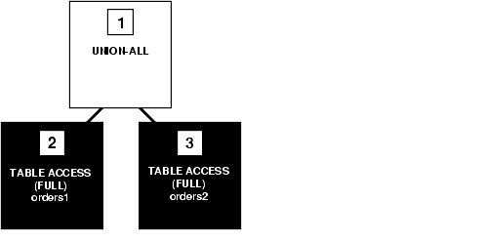
Text description of the illustration pfgrf205.gif
To execute this statement, Oracle performs the steps in Figure 2-7 in the following order:
- Steps 2 and 3 perform full table scans on the orders1 and orders2 tables.
- Step 1 performs a UNION-ALL operation returning all rows that are returned by either step 2 or step 3 including all copies of duplicates.
The query in Example 2-50 uses the UNION operator to select all parts that appear in either the orders1 or orders2 table.

Example 2-50 How the CBO Executes Compound Queries with UNION
SELECT part FROM orders1
UNION
SELECT part FROM orders2;

Figure 2-8 shows the execution plan for this statement:

Figure 2-8 Compound Query with UNION Set Operator
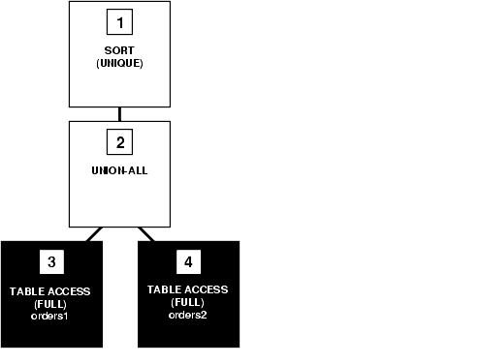
Text description of the illustration pfgrf206.gif
This execution plan is identical to the one for the UNION ALL operator shown in Figure 2-7, except that in this case, Oracle uses the SORT operation to eliminate the duplicates returned by the UNION ALL operation.
The query in Example 2-51 uses the INTERSECT operator to select only those parts that appear in both the orders1 and orders2 tables.

Example 2-51 How the CBO Executes Compound Queries with INTERSECT
SELECT part FROM orders1
INTERSECT
SELECT part FROM orders2;

Figure 2-9 shows the execution plan for this statement:

Figure 2-9 Compound Query with INTERSECT Set Operator
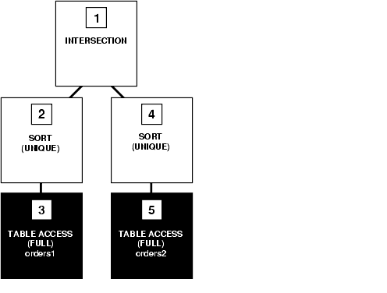
Text description of the illustration pfgrf207.gif
To execute this statement, Oracle performs the steps in Figure 2-9 in the following order:
- Steps 3 and 5 perform full table scans of the orders1 and orders2 tables.
- Steps 2 and 4 sort the results of steps 3 and 5, eliminating duplicates in each row source.
- Step 1 performs an INTERSECTION operation that returns only rows that are returned by both steps 2 and 4.

http://www.cise.ufl.edu/help/database/oracle-docs/server.920/a96533/opt_ops.htm#1005536

